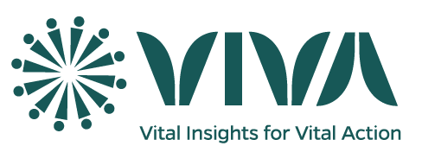**THE EVENTS RECORDINGS BY CSAs**

**Cluster Events Recording:**

CSAs visit homes within their clusters to record events, the events include deaths, pregnancy outcomes and pregnancies (The pregnancies are monitored mainly to ensure no pregnancy outcomes are missed). On any of these occasions the responders are consented and household phone numbers updated.

**Events Recording Tools:**

1. Pregnancy Paper Tool (docx)
2. Pregnancy Outcomes Paper Tool (docx)
3. Death Paper Tool (docx)
4. Events Reporting ODK Tool (xlsx)

The 3 events forms are combined into one data capturing application. Variables names reflected those on the paper form.

Two tables will be generated; Mother (Events) and Child (List of live births) allowing for 1: many linkages using the key (in Mother) to the parent_key (in Child).

**Data Items:**

1. Household level:

1. Location
2. Household name
3. Phone availability
4. Phone numbers

2. Individual level (about the event):

1. Full names (including surnames)
2. Age (completed years)
3. Sex
4. Event date in the case of Pregnancy Outcome and Deaths

**General Principle for the ODK Design:**

1. Variables names reflected those on the paper form.
2. Notes and other ODK administrative variables had names stating with “na_”.
3. Name for “begin group” start with “bg_#” and the same name applied to the respective “end group”.
4. Name for “begin repeat” start with “br_#” and the same name applied to the respective “end repeat”.
5. To reduce key board strokes and therefore errors, items 2-7 on the paper forms were reduced to a single item “APE_code” which has some validation controls. While HH8-HH9 became WA code (settlement of the cluster).